Gender Gap in Employment

Ritika Bhardwaj

([rb2g22@soton.ac.uk](mailto:rb2g22@soton.ac.uk) / 3039066)

# Data Story Summary

In the 21st century, women have made great strides in many areas of society. They are now more educated than ever before, and they are making their mark in all walks of life. However, there is still a long way to go for women to achieve equality in the workplace. Achieving gender parity is necessary for any economy to reach its full potential. The aim of this data story is to illustrate the **gender gap in employment**.

The target audience includes policy makers, social workers, government ambassadors and diplomats, journalists, feminists, and curious public. Any individual who wants to understand the plight of women in workforce can use this data story. The story covers many scenarios like students wanting to write an article for assignment, diplomats taking policy making decisions, ambassador monitoring progress of governmental efforts towards gender parity, journalist looking for a new story to cover, etc. Information needs of users include – knowing whether employment gap exists, the distribution of paid and unpaid work in households (are women confined to their homes?), countries with high pay gap between men and women, the trend in gender pay gap in different countries and women in leadership roles.

The overall narrative pattern is **argumentation** because the data story presents and supports (arguments) theexistence of gender gap in employment. Target audience wants to compare the different measures for gender parity in employment. The data story has visualisations that primarily compare different gender parity measures (the participation rate, workload distribution) between men and women. Patterns for **engagement** are also used by adding interactivity (explore) at the end of linear narration.

# Dataset Summary

There are multiple data sources for this data story. Three datasets - labour force statistics [1], time spent in paid and unpaid work [2] and gender wage gap [4][5] are taken from OECD database. OECD database was used because it is one of the world's largest and most trusted sources of comparable statistics and data. It collects data in public policy areas such as employment, agriculture, environment, and education.

Another data source is a report called ‘Let’s get real about equality: When women thrive 2020 global report’ [3]. The report is made by analysing over 1100 organizations across the world by Mercer. This data is used to create a funnel chart to show female representation in leadership roles.

The labour force statistics dataset [1] had to be cleaned before visualising. Rows with missing values and indicator column were removed. Only the statistics from the latest year for each country were kept, rest removed. This dataset will tell the audience that the gender gap in employment exists as from initial analysis it is found that the participation rate of women in labour force is much less compared to men.

Paid and unpaid work dataset [2] had no missing values. The columns with total work done by men and women were removed. Indicator and time was removed. The columns were renamed and reformatted to have time spent in paid and unpaid work by men and women in 4 separate columns. This dataset will show the audience the uneven distribution of household and childcare responsibilities (unpaid work) between men and women.

An excel file for representation of women at career levels was created from scratch using the information given on page 17 of mercer’s report [3]. This dataset would tell the audience that women are denied promotion to high paying jobs.

By joining two datasets [4] and [5], gender wage gap dataset is created. When joining, latest values added, and some changed. There were missing values for certain years. Missing values were imputed using **forward fill**. Forward filling means fill missing values with previous data. Country code of each country was converted to country name using ‘geography’ feature (data -> geography) of excel and then the datatype of the column was converted to text. Self-employed was removed and only rows under employee category were kept. Only two columns with country names and gap values were kept and rest removed. Gender pay gap is one of the most crucial measures for checking the progress towards gender parity in employment. The visualisation of the dataset will tell the audience the trends in the gender pay gap in many countries.

# Visualisations

## Labour force statistics of men and women – Butterfly chart

### Description

The chart shows the labour force participation rate of men and women in different countries across the world. Use case is that audience can see the huge gap between the percentage of labour force of men and women inferring that gender employment gap exists.

The chart also compares the percentage of women in workforce across different countries. The countries with very less female participation in workforce will be clear to the audience from the butterfly chart.

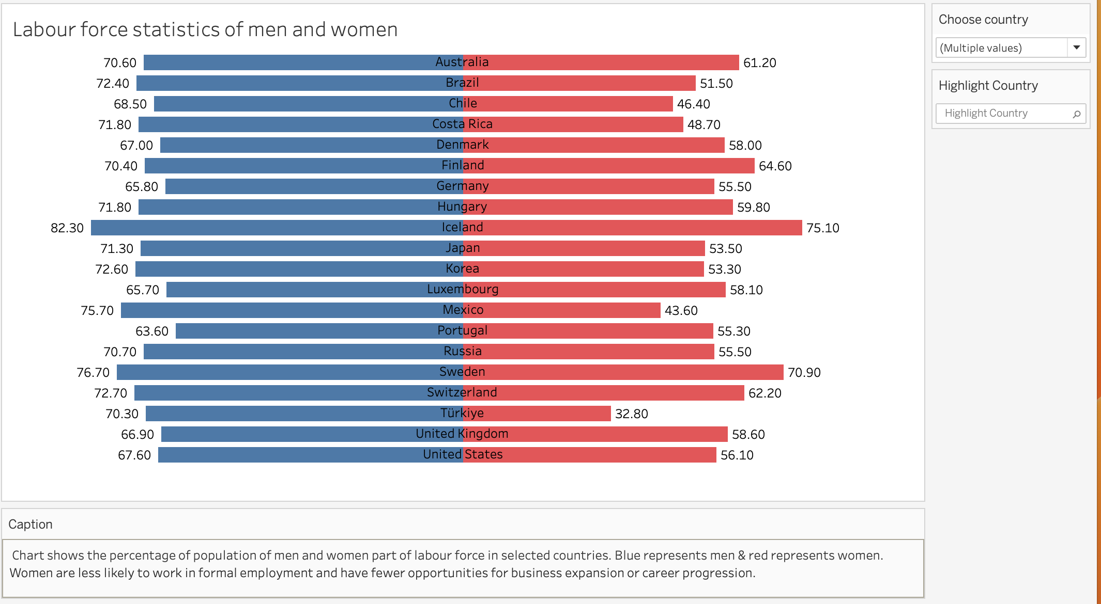

Figure 1: Butterfly chart

Since there are many countries, highlight country interaction has been provided to the audience to highlight a country from the list of selected countries in the visualisation. Audience will also have the option to include or exclude countries from visualisation according to their needs. For example, if users want to compare between the European countries, they can filter out other countries.

### Justification

Butterfly chart (also known as tornado) is a type of bar chart used to compare two data series side by side making comparison easier. In this visualisation, the chart compares the labour force statistics of men and women side by side. Bars (visual encoding) can easily compare the differences in data because the reader can quickly spot which bar is larger and shorter, and spot relative differences.

Colour (retinal encoding) is used to represent men and women. A warmer colour (Red) for women and cooler colour (blue) for men is chosen for easy comparison.

In a few countries, the difference between labour force of men and women is small. So, to avoid any confusion or bias, the bars are labelled with the percentage for easy comparison.

### Narrative Design Patterns

The narrative design pattern used here is **explore-compare**. A comparison between the participation rate of men and women in labour force is drawn. Side by side presentation (juxtaposition) of two bar charts using butterfly chart is done which makes comparison easier for the audience. It will be clear that gender gap in employment exists as there is a significant gap in participation rate of men and women in workforce. Audience engages with the chart by interactively exploring the chart and choosing the countries and highlighting a country as per their needs.

### Strengths and Weaknesses

Strengths:

* Two comparisons – labour force participation rate of women in different countries and labour force participation rate of men and women, implemented using butterfly chart.
* The lowest and highest values are easily visible. Bars make it easy to compare data.

Weaknesses:

* Currently the visualisation only shows labour force statistics in OECD and a few non-OECD countries.
* Bars fail to show patterns.

### Improvements

More data sources can be incorporated to get data on labour force statistics in other countries.

By adding data for labour force statistics for past few years, then using line chart, the patterns, and trends in the labour force statistics over the years can be identified. Currently, this data is not available.

## Distribution of paid and unpaid work by gender – stacked bar chart

### Description

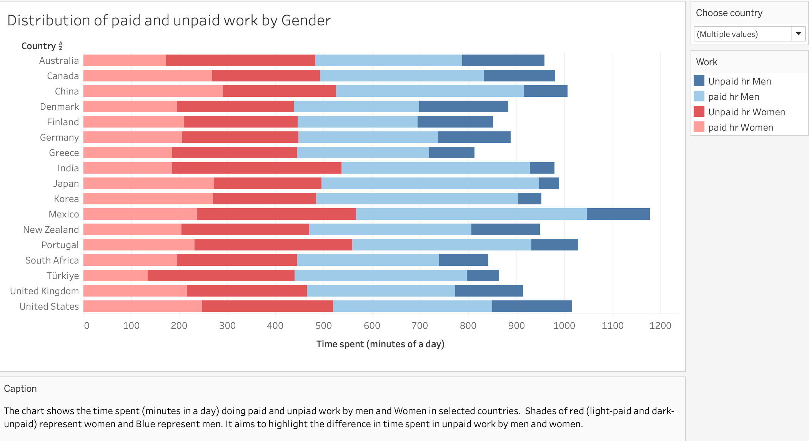

Figure 2: Stacked bar chart

The stacked bar chart shows the time spent in paid and unpaid work by men and women in different countries. Audience can compare the paid work and unpaid work between men and women in each country and compare it between countries. This chart follows the use case when target audience can easily identify the uneven distribution of unpaid work.

Interactivity is added in the chart by giving option to user to choose countries to include in the graph. This way audience can compare the distribution of work in chosen countries as per their needs.

Stacked bar charts uses colour and length coding. Colours (retinal encoding) such as blue for men and red for women are used.

### Justification

A stacked bar chart is used to show composition and comparison. Horizontal bars are used as it is easier to display and read and because nominal variables are being graphed. It is easier to compare between the compositions (paid and unpaid work by men and women) of bars (visual encoding) using stacked bar chart.

To avoid any bias or confusion, very light and very dark shades of colour are used to represent paid and unpaid work. Shades of same colour (red and blue) represent work by each gender following the Gestalt similarity principle. Lighter shades for paid work and darker shades for unpaid work are chosen to show the high difference in time spent in **unpaid work** by men and women to the audience.

### Narrative Design Patterns

The aim of the data story is to compare the difference between women and men as reflected in social, cultural, or economic attainments or attitudes focussing on the employment sector. This visualisation compares the difference between the time spent in paid and unpaid work by men and women. The narrative design pattern used here is **compare** (argumentation). The comparison shows the that women spend more time in unpaid work activities which constrains the paid work opportunities leading to a disadvantage relative to men.

### Strengths and Weaknesses

Strengths:

* Easy to compare the unpaid work
* Interactivity lets the users choose countries according to their needs.

Weaknesses:

* Scalability issues with bar charts (there might not be enough room on screen to have white space interleaved between the distinguishable bars) if the user selects all countries.

### Improvements

To compare the total work done by men and women, grouped stacked bar chart can be created to include total work along with paid and unpaid work. This could show that women perform more total work compared to men as along with paid work, they are given sole responsibility of unpaid work.

## The Higher Up the Corporate Ladder, the Fewer Women - Funnel chart

### Description

The visualisation shows the representation of women at different career levels. It shows the percentage of women in the corporate pipeline at each rank/position. Target audience can clearly see the leaky pipeline for women in leadership. As the career level progresses, the percentage of women decreases.

Retinal encoding used is saturation (shades of red).

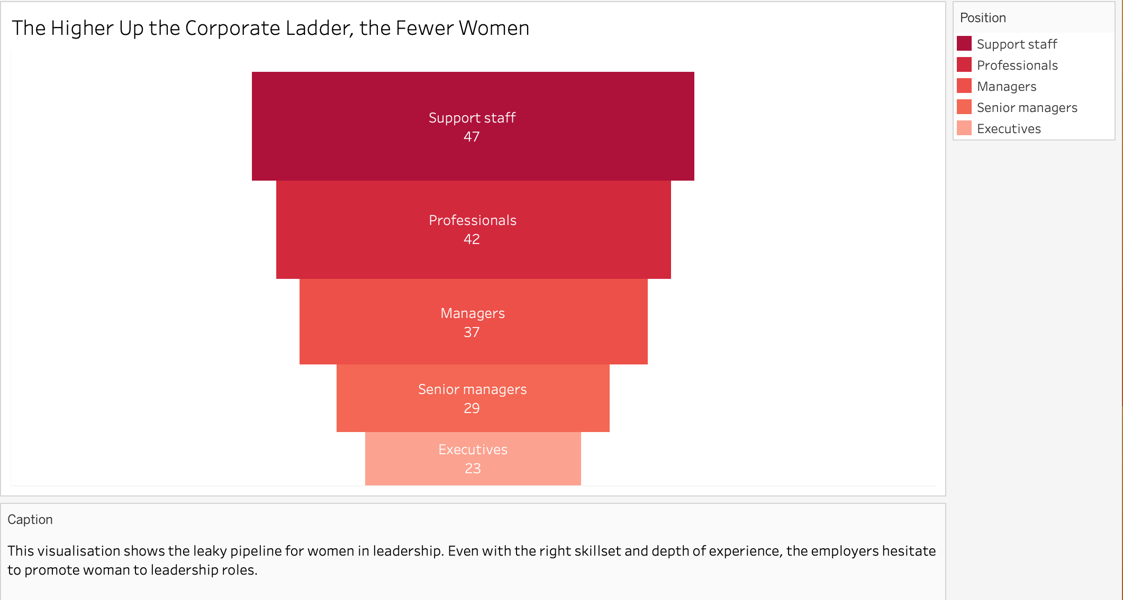

Figure 3:Funnel chart

### Justification

Stepped bar-style funnel chart is used because the data is decreasing sequentially and has more than 4 stages (ranks/positions). The funnel shape makes it easier for audience to understand the decreasing representation of women in the corporate ladder. Shades of red colour are used because previous visualisations used red to represent women. The shade of red gets lighter going down the funnel to show that the number of women is decreasing.

### Narrative Design Patterns

Narrative design pattern is **gradual reveal** by first showing the representation of women in low paying roles and then gradually revealing the number of women as the rank of job increases (high paying jobs). This way user will find the bottlenecks, and eventually infer that women are denied promotions to high paying jobs. Funnel chart shows the leaky pipeline for women in leadership.

### Strengths and Weaknesses

Strengths:

* The funnel chart clearly shows a natural progression or regression in this case of value (number of women) over different ranks in corporate.

Weakness:

* The chart does not give any information about the representation of men at different career levels for comparison.

### Improvements

Another data source can be incorporated to include data on the percentage of men at different career levels. A butterfly chart or grouped bar chart can be created to show the comparison between number of men and women at different ranks or positions.

## Gender pay gap over the years – Line chart

### Description

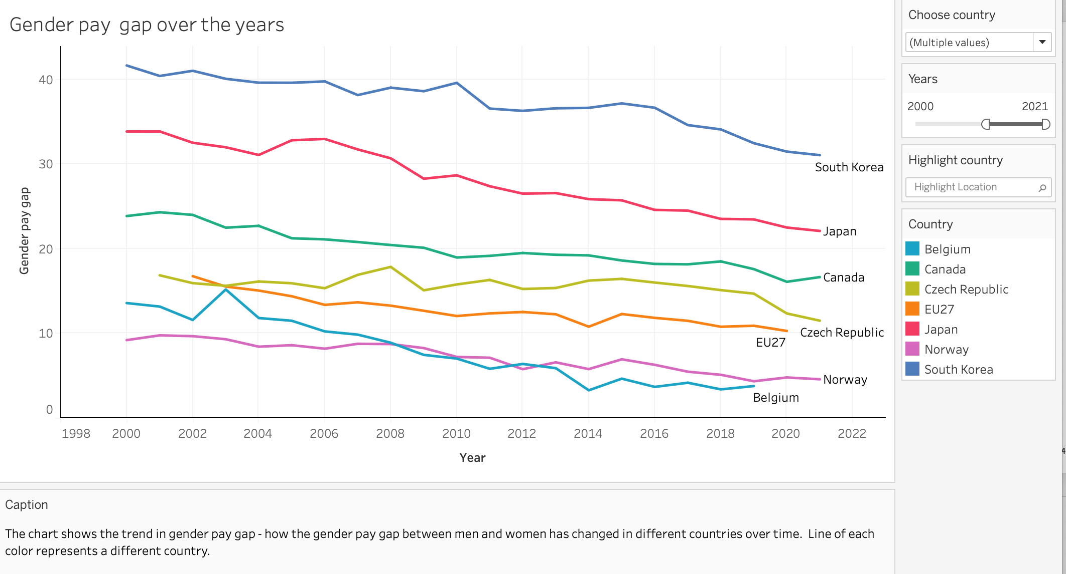

Figure 4: Line chart

The line chart illustrates the gender pay gap in different countries over the years. Line visual encoding and colour retinal encoding is used. Use case here is that audience can compare the progress in closing gender gaps between countries. The progress in governmental efforts for closing the pay gap can be monitored using the chart. The chart shows that some countries still have a huge pay gap while for certain European countries the gap seems to be closing.

As there is large amount of data (multiple lines) in the chart, the user might want to explore the data interactively and highlight a specific mark (line) while still maintaining the context of where the mark (line) is in the view/chart. The highlighter immediately highlights the country selected by user.

2 filters are also added for interactivity. The user can choose the country whose data should be included in the chart. The user can also modify the range of years. This way the audience can see how the gender gap has changed over the selected period of time as per their needs.

### Justification

Line chart is used to identify the trend in the pay gap data. It tells how the pay gap has changed (decreased or increased) over the years for different countries. Movement is easier to spot in line chart.

As there are many lines (countries) so to avoid any confusion, highlight interactivity is added so that user can highlight any selected country in the chart. Also, each line is labelled with country name to avoid confusion.

### Narrative Design Patterns

Narrative design pattern used is **Exploration** (patterns for engagement). Standing at the end of narration, the line chart depicts the progress of different countries towards closing gender gap. Users can interact and explore the chart, choose countries and range of years according to their needs. Users can see on their own how the gap changes at what time period, deduce reasons for sudden change (e.g.: could be due to a new policy implemented) and explore the chart.

### Strengths and Weaknesses

Strengths:

* If the same data was in a table or bar graph, it would have been very difficult to learn patterns and trends from the data. Smaller changes over time is best visualised using line chart.
* The trend of gender pay gap for countries is clear and visible.
* Exploration gives audience the control over the interactions with the story’s content.

Weaknesses:

* If the user chooses too many countries, then plotting these lines on the chart will make the visualisation look cluttered and hard to read.
* The visualisation talks only about the current situation and not about the future (does not forecast the pay gap).

### Improvements

New data source can be incorporated to get further data on pay gap for other countries for the past 4-5 decades and forecast of the pay gap can be added in the line chart. The audience will then be able to not only see the current trend in pay gap but will also know how the pay gap will change for the next few years.

# REFERENCES

[1] [*Labour force participation rate, by sex and age group*](https://stats.oecd.org/index.aspx?queryid=103872) *:*

<https://stats.oecd.org/index.aspx?queryid=103872>

## [2] [Time spent in paid and unpaid work, by sex](https://stats.oecd.org/index.aspx?queryid=54757) :

<https://stats.oecd.org/index.aspx?queryid=54742>

Left hand menu -> employment -> choose Time spent inpaid and unpaid work, by sex

[3] Mercer’s report on ‘Let’s get real about equality’, Pg 17

Link: <https://www.mercer.com/content/dam/mercer/attachments/private/gl-2020-wwt-global-research-report-2020.pdf>

[4] <https://data.oecd.org/earnwage/gender-wage-gap.htm>

Download full indicator data (Download option above bar chart)

[5] Gender wage gap: <https://stats.oecd.org/index.aspx?r=10783>

# APPENDIX

## Personas, Scenarios and Use Cases

**Erica Brown**

She is a 32-year-old, American citizen, currently working at Association for women’s rights in development (AWID) headquarters at Toronto. She completed her bachelors at an Ivy league school – University of Chicago in psychology in 2010. She worked with a local organization for a few years at Oak Park, helping young women and children tackle discrimination. After pursuing her master’s in MSW program from Columbia university, she joined AWID. She has recently been promoted and given the responsibility of coordinating with activists and policy makers worldwide to influence gender policies and practices.



**Scenario:** Erica is planning to start a campaign with some activists on equal pay for women. She needs to decide what countries to focus on and which activists to contact. She needs to allocate her resources and money to different activists according to the extent of pay gap and formulate a plan for the campaign.

**Use case:** She comes across a data story on gender gap in employment. This talks about exactly what she needed. She finds information about the percentage of women currently employed in different countries. She decides to allocate more resource and have more activists and a bigger campaign in the top 5 countries with highest employment gap between men and women. Using the visualisation of distribution of paid and unpaid work, she finds the regions and countries where women do more unpaid work. She modifies her plan for campaign to educate women on equal distribution of household responsibilities. The funnel chart for women in at different career levels helps her understand that women are not promoted to policy making decisions. She adds another agenda in campaign - promote women in leadership roles. Scrolling down further, she finds the visualisation on the gender pay gap. She understands the trend in pay gap in different countries. She explores the chart, modifies years, and selects different countries for comparison. Certain countries’ policies seem to be working on closing the pay gap, so she focuses less on them. She plans to contact activists from countries where the gender pay gap does not seem to be closing soon.

**Alma Oscar**

She is a 35-year-old ambassador at the OECD council. She lives in Denmark. She is married with 2 kids. OECD is inter-governmental organization whose goal is to shape policies fostering prosperity, equality, and opportunity for all. Alma is very outgoing and possess excellent social skills. Alma is responsible for contributing towards policy making decisions based on the findings from the data released by OECD.

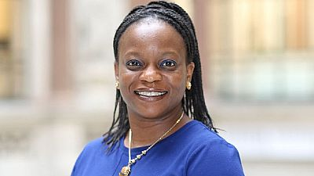

**Scenario**: She is given the task to work on policy making for HR and women empowerment ministry to bridge the pay gap between men and women. She wants to find countries performing better in closing gender gaps, understand their policies and implementations and then formulate policy.

**Use case:** She finds a data story on gender pay gap in employment. This information could be of critical use for policy making decisions. She uses the visualisation and data for percentage of women employment as a benchmark to check for progress towards gender parity across different OECD countries. She intends to find the top 5 and worst 5 countries. Being an ambassador for Denmark, she compares the gender gap in employment. Using the highlight country interaction, she highlights Denmark. The visualisation for time distribution of paid & unpaid work benchmark the progress towards work-life balance and changes in societal norms. She comes across the visualisation of women at different career levels. She uses this to add policies that ensure women do not get discriminated when getting promoted and they get same opportunities to work in leadership roles.

**Akshita Pathania**

She is 21 years old, born and brought up in India and then moved to UK for higher studies. She is completing her undergraduate study at University of Edinburgh in international relations. She is an introvert. She loves doing research and learning new things. Her current interest is learning about the economic and political issues around the world. Her goal is to join foreign service as a diplomat and represent her country at one of its embassies or consulates.



**Scenario:** Akshita is studying a module called human rights as part of second semester. She is given an assignment to write an article on existing socio-economic problems. She has chosen her topic - gender inequality. On initial research she realises, gender inequality is a vast topic covering several sub-topics.

**Use case:** Akshita searches about gender inequality on the internet and tries to find a specific subtopic to write a one-page article as part of the assignment. She come across a data story on gender gap in employment. On reading, she understands the plight of women in employment through a visualisation on employment/population ratio. Then, she finds a visualisation showing representation of women at different ranks in corporate. She writes in the assignment that woman are confined to low-paying jobs using the numbers given in the visualisation. She also finds a visualisation on distribution of paid and unpaid work by gender and adds in the assignment that women are forced to handle unpaid responsibilities along with paid work. She finds the trend in the gender pay gap in different countries. She uses the filter to select countries of her choice (countries with highest GDP) and then researches further on them to include in the assignment.

**Oliver Smith**

He is 25-year-old journalist, working at 7News in Sydney, Australia. He completed his bachelor’s in journalism from James Cook university. His goal is to have his own news channel and empower every mind with the right information. He feels comfortable using technology, laptop, and phone. His hometown is Newcastle, but he moved to Sydney for better job opportunities. He recently joined 7News. He is a research journalist who finds and verifies information on a wide range of issues. He writes, edits and files news stories and articles creating awareness on different economic and social problems.



**Scenario:** Being a feminist, Oliver’s next story is about the future of women in employment. His junior has given him some initial data, he needs to verify it and add more content to it.

**Use case:** He finds a data story on gender gap in employment. Scrolling down he finds a visualisation and some data on the gender pay gap in different countries (including Australia). He uses this data to write in which countries, the gender gap is closing while which countries need to work on their policies and efforts to close the gap. He uses highlight interaction to focus on Australia and compare it with other countries. He come across a visualisation on women representation in different career levels. He includes the visualisation and its conclusions to the story. Further scrolling, he comes across another visualisation on gender pay gap over the years. He learns about the trends in gender pay. Gap and how Australia is working towards closing the pay gap compared to other countries.

**Gina Muller**



She is 30-year-old women, from Berlin, Germany. She works at the headquarter of UN women. She is an avid reader. Helping people is her passion and profession. After facing gender inequality in her early career as a manager, she changed her profession and joined UN women which is dedicated to global gender equality and empowerment of women.

**Scenario:** She must monitor the progress of governmental efforts towards gender parity and compare the progress of with other countries.

**Use case:** She finds a data story on gender gap. The visualisation on labour force statistics tells her about the countries with high difference in participation rate of men and women that need to work on implementing better policies. She compares the progress of different countries in closing the gender pay gap using a line chart on the gender pay gap over the years in the data story. She explores the chart by filtering in and out countries of her choice and choosing year ranges. She checks for the years when a new policy was introduced and if that policy’s implementation had affected the pay gap.